**CLINICAL PORTAL**

Users:

Admin, Doctor, Patient, Pharmacist.

Users can login to their respective pages using email and password. If not registered they must register before login.

**Admin**

Admin is created with email: abcd@gmail.com and password:123456.

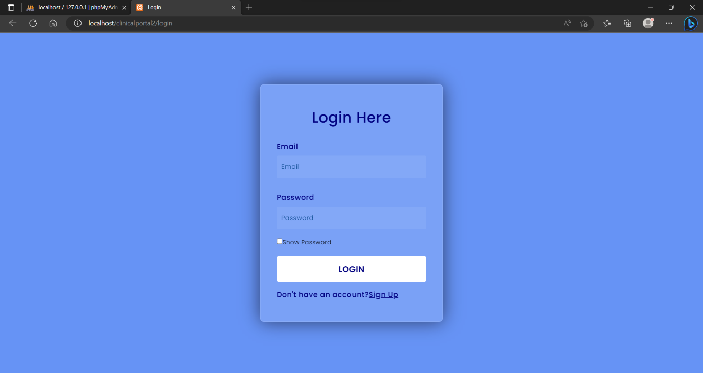

Admin can create new doctors and pharmacists.

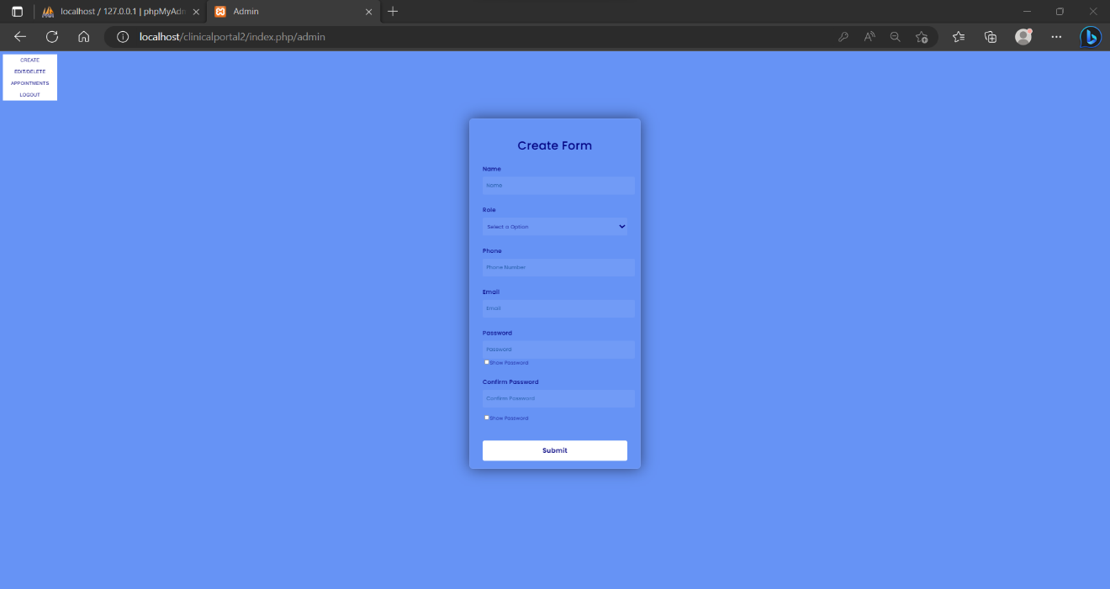

They can view the list of all doctors and pharmacists and edit or delete them if necessary.

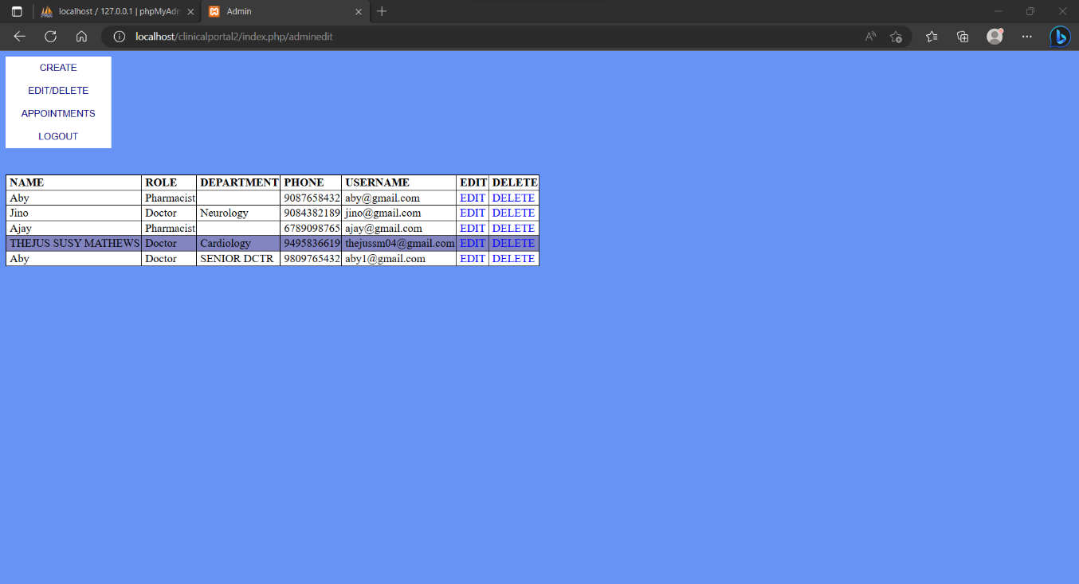

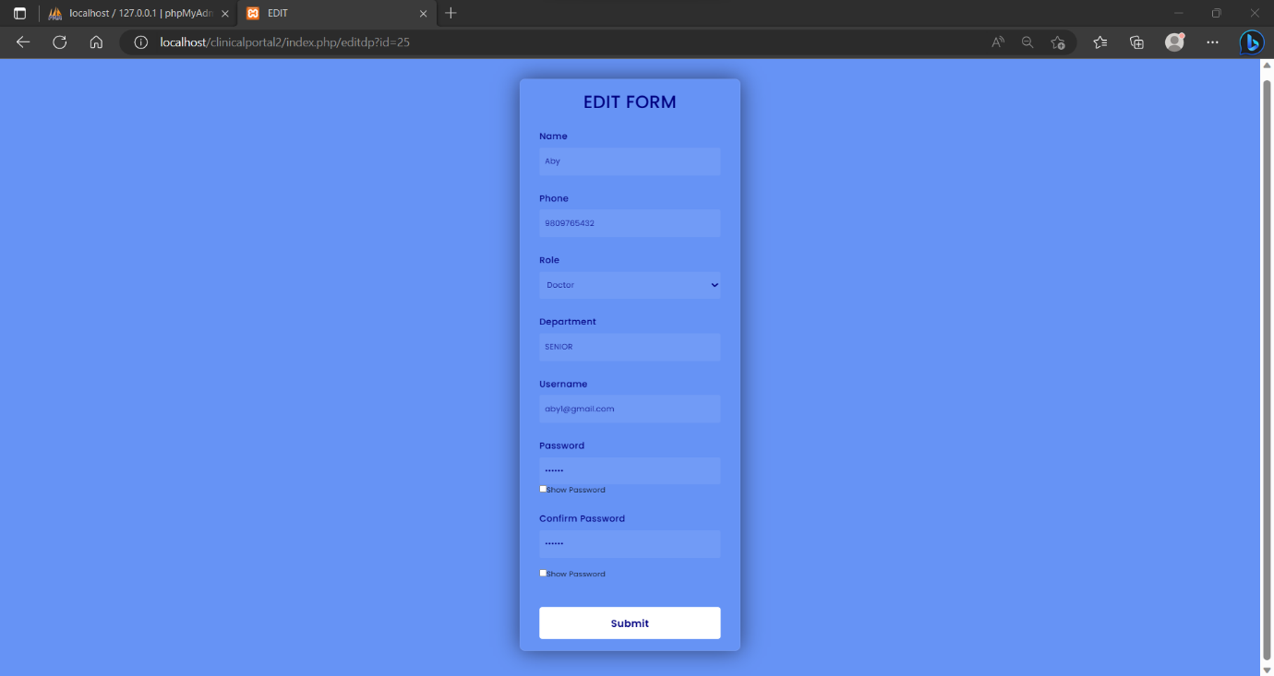

Admins can see the whole appointments of particular doctor.

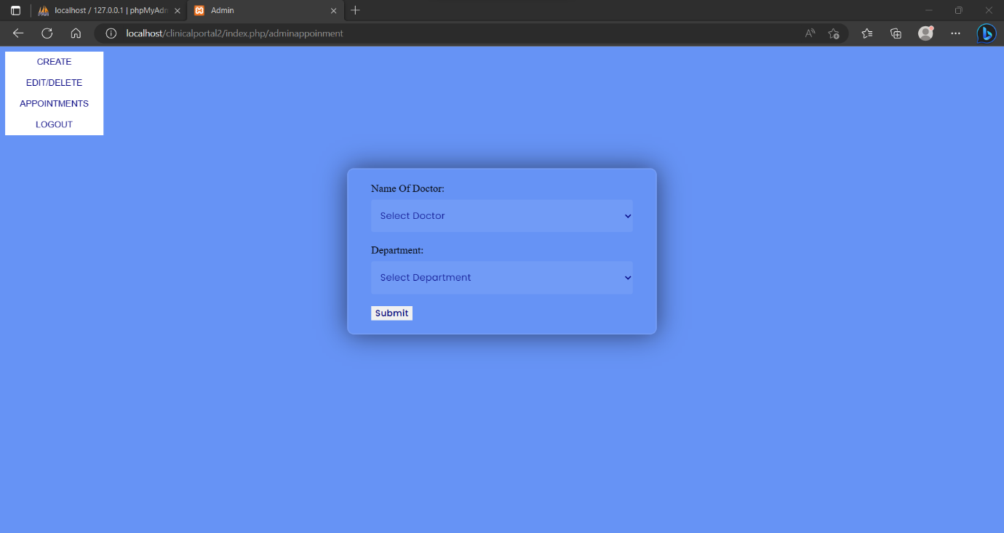

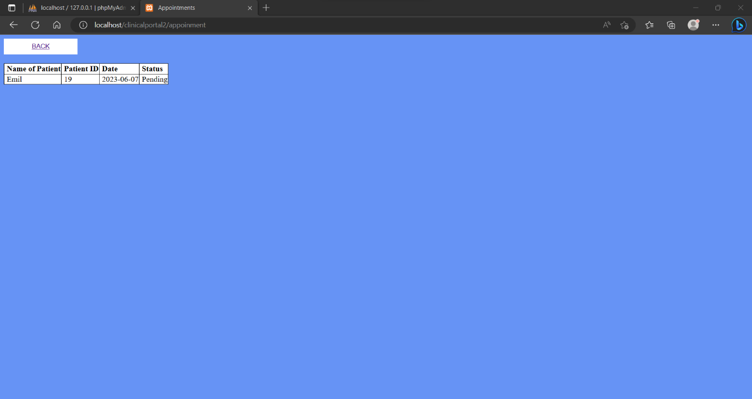

**Doctor**

They are able to view their patients appointments.

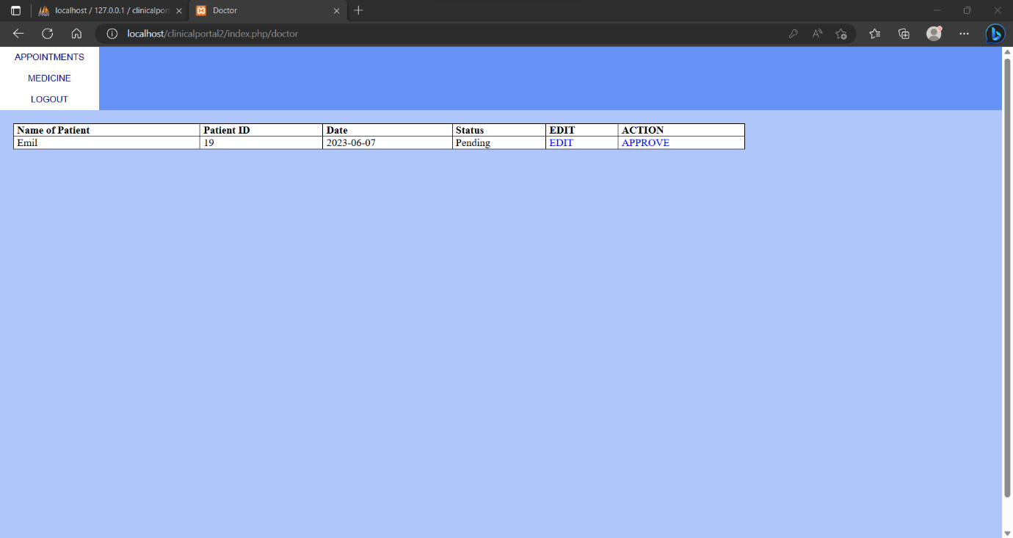

They can accept the appointment of a particular patient by clicking the APPROVE button. If no appointments found that information is diaplayed. Also can reschedule it within 5 days from date of appointment by clicking EDIT.

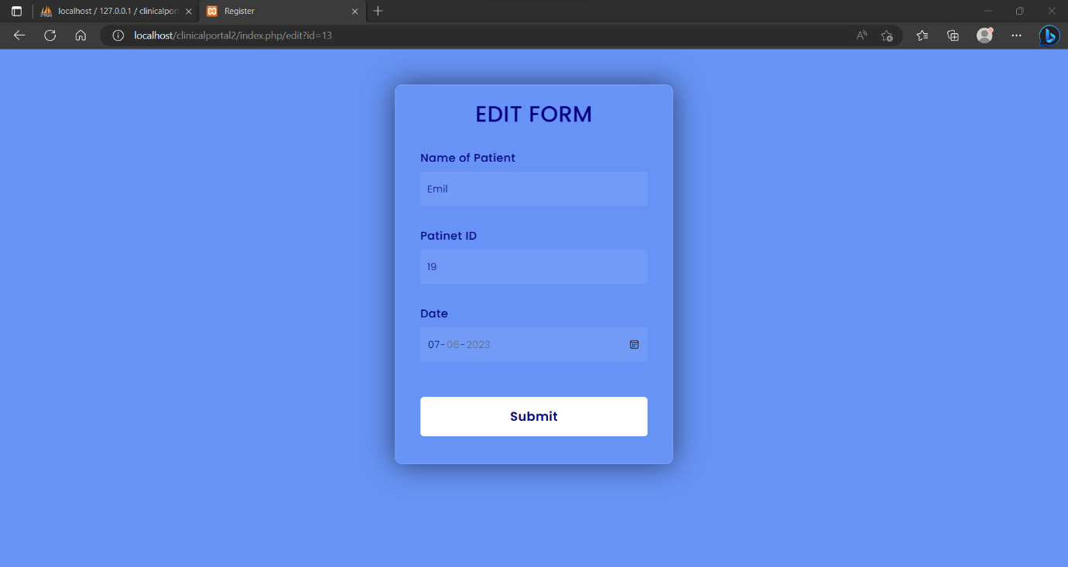

Doctors can prescribe medicines for patients whose appointment is accepted. If no appointments are approved NO PATIENT IS FOUND FOR PRESCRIBING MEDICINE is displayed.

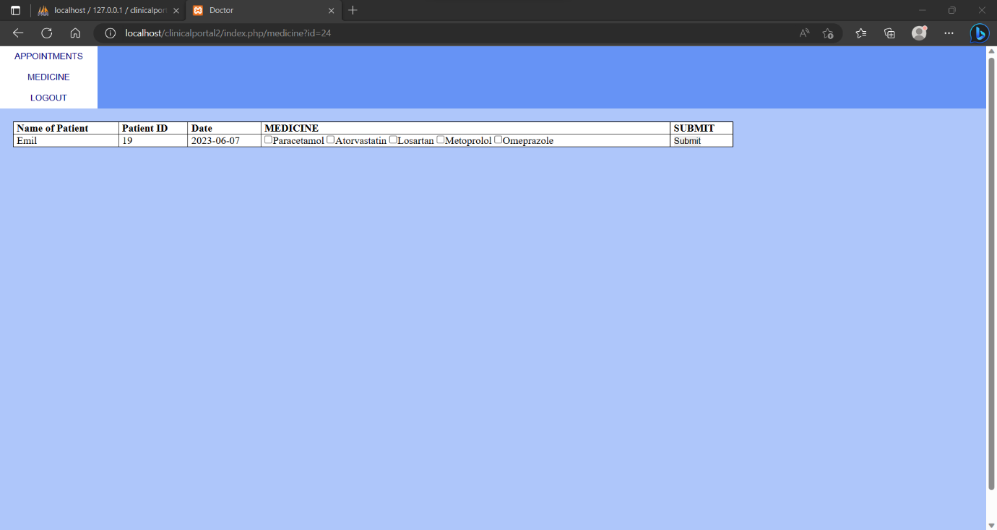

**Patients**

By registering for new account the user is automatically registering as a patient.

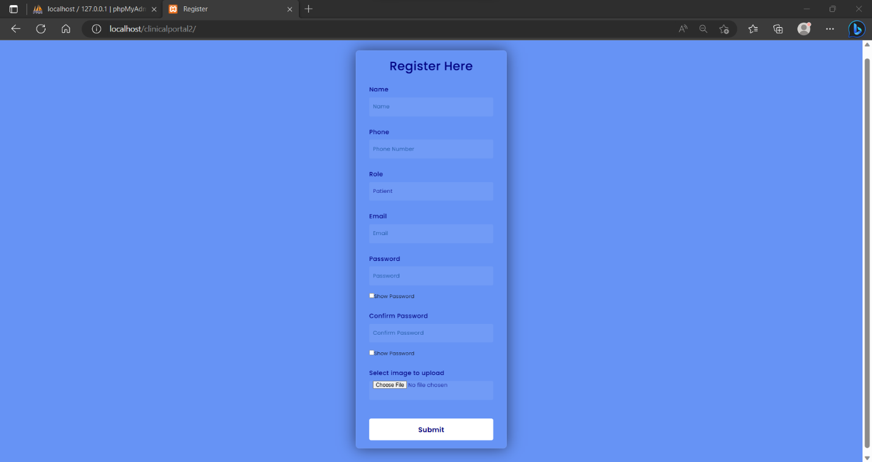

Patients can book an appointment for any doctors. If such doctor with department is not found a warning message is displayed.

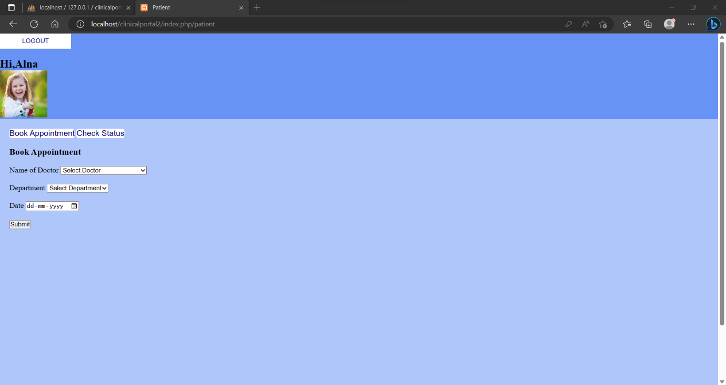

They can view the status of appointment and if no appointment found that message is displayed. If the appointment is approved by the doctor and if the medicine is prescribed they can view them.

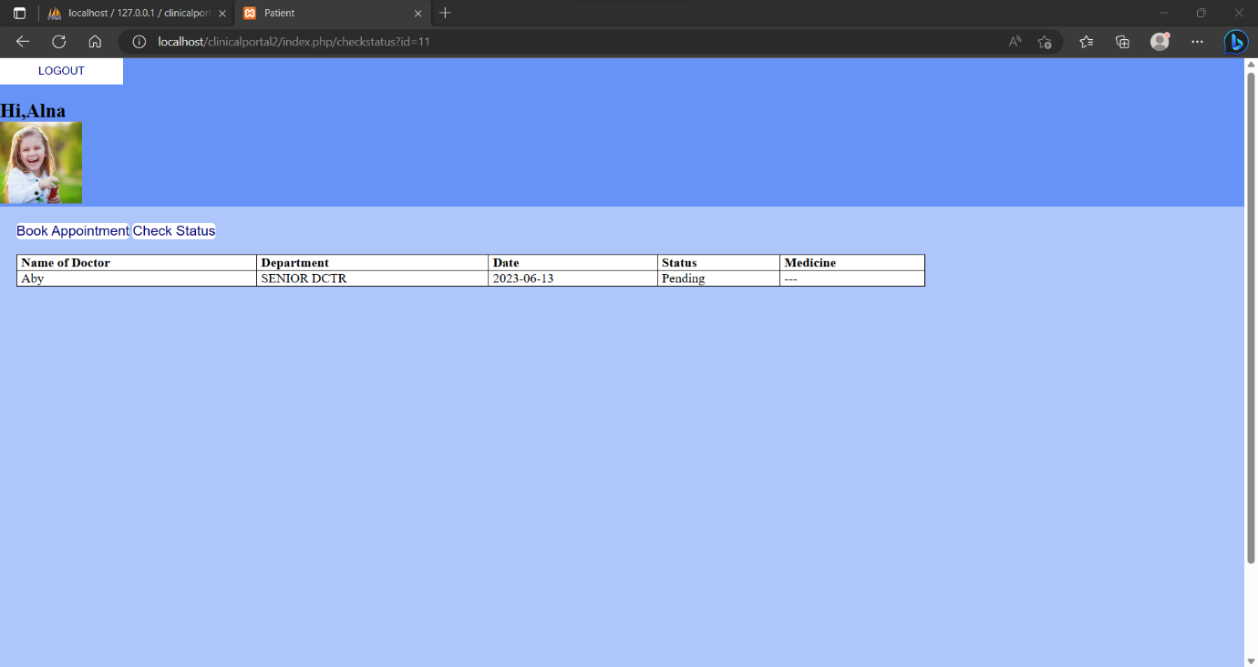

**Pharmacist**

They can simply login to their account after they are registered by admin.

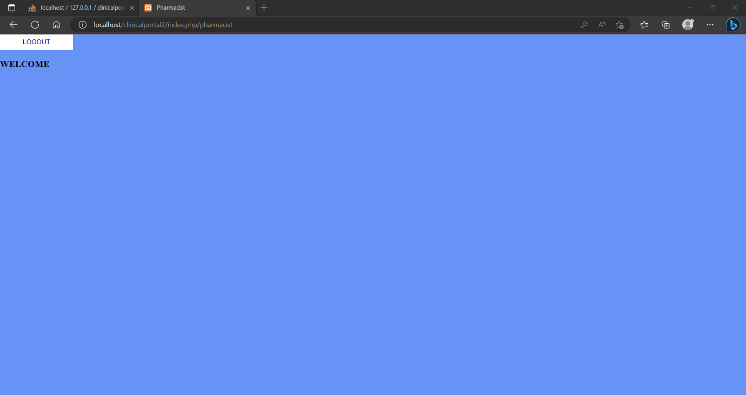

All users can logout from their account through LOGOUT button provided.